Lab 1 Network Commands

1. **tcpdump**

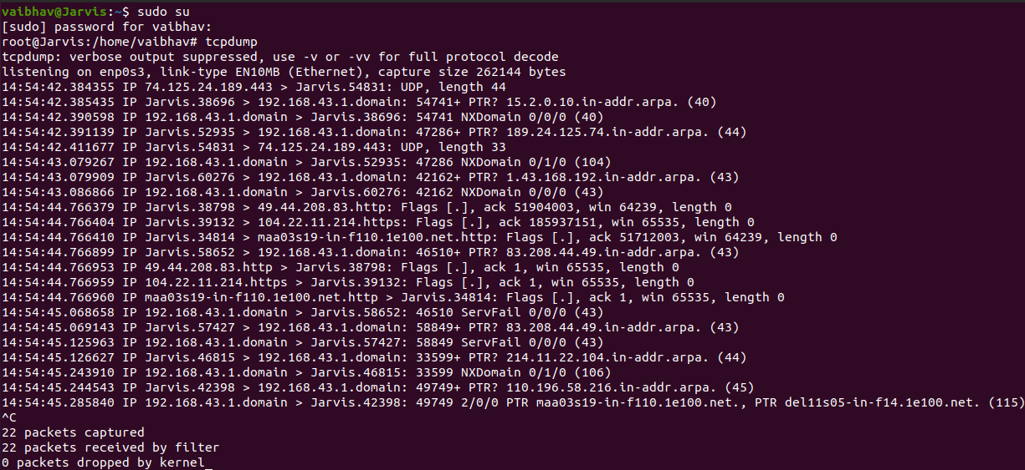

**tcpdump** command allows the user to display the information of the packets that are being received or transmitted over the network connected to the computer. It prints the contents of the network packets.

This description comes along with the time at which the packets are being transmitted and received and also the information of two machines among which they are being transmitted.

1. **ifconfig**

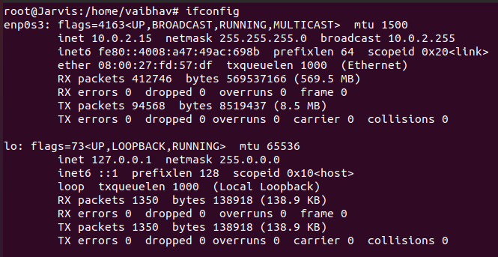

**Ifconfig** is used to configure, enable and disable the network interfaces. It displays the status of the currently active interfaces. It can also be used to set the IP Address and netmask of the network interface.

1. **dig**

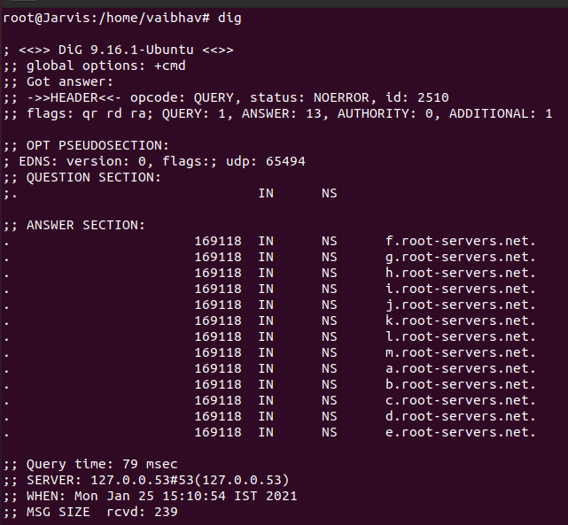

**dig(Domain Information Groper)** is used to receive information of DNS name servers. It displays the answers to the query provided that are returned from the server names specified. It also gives us information about the query time, the server, when was the query made and the message size received.

1. **arp**



**arp(Address Resolution Protocol)** is used to display/manipulate the kernel’s IPv4 neighbor network cache. It can find the MAC Address of a network neighbor for a given IPv4 Address.

1. **netstat**

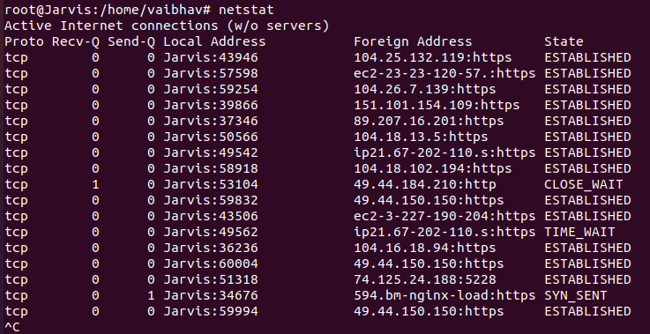

It gives information about the Linux Networking Subsystem. It displays a list of open sockets.

1. **telnet**

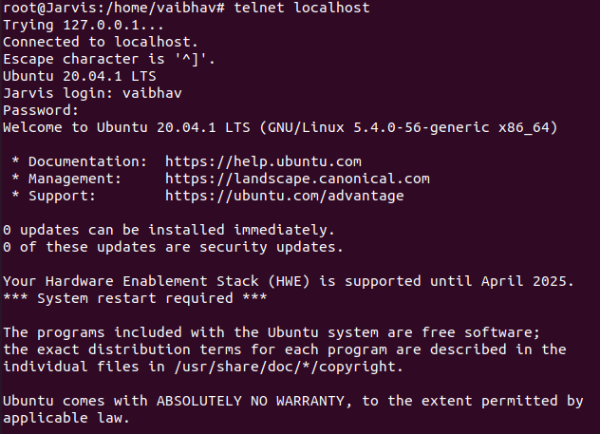

**telnet** command is used to provide a bidirectional interactive text-based communication facility using the TELNET protocol.

1. **traceroute**

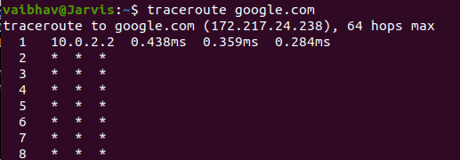

**traceroute** prints the path taken by the package to reach the host. It gives info about all the hops that a packet takes to reach the host machine.

1. **ping**

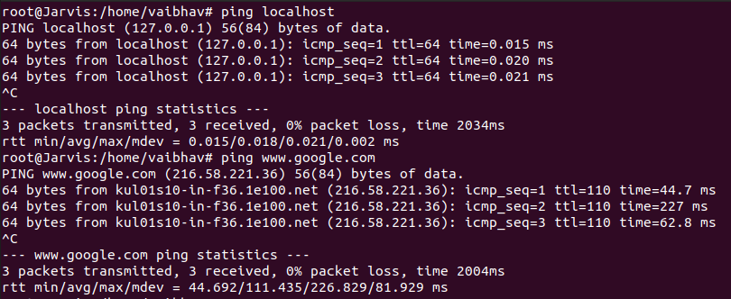

**Ping (Packet Internet Groper)** is used to check the network connectivity between the host and server/host. This command takes as input the IP address or the URL and sends a data packet to the specified address with the message “PING” and get a response from the server/host this time is recorded which is called latency.

1. **top**

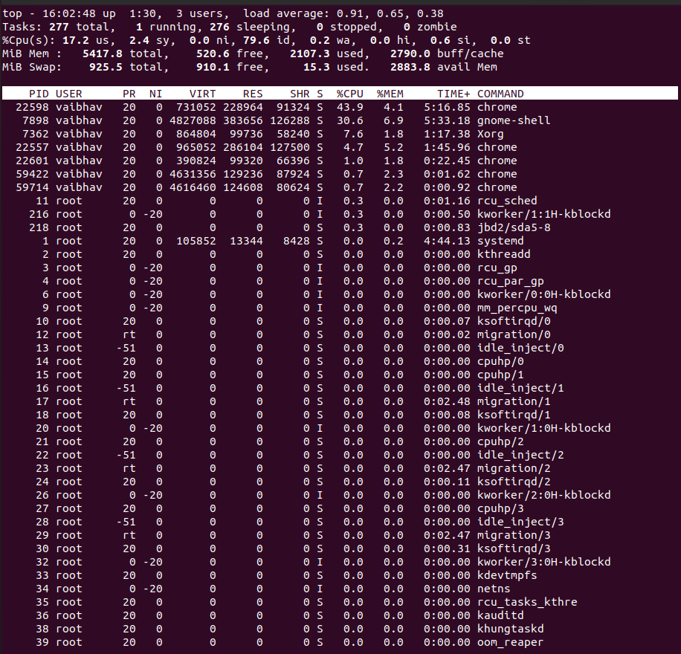

**top** provides a dynamic real-time view of the Linux Processes. It displays information about the processes and the threads that are currently managed by the kernel.

1. **wall**

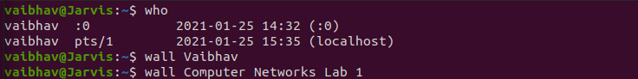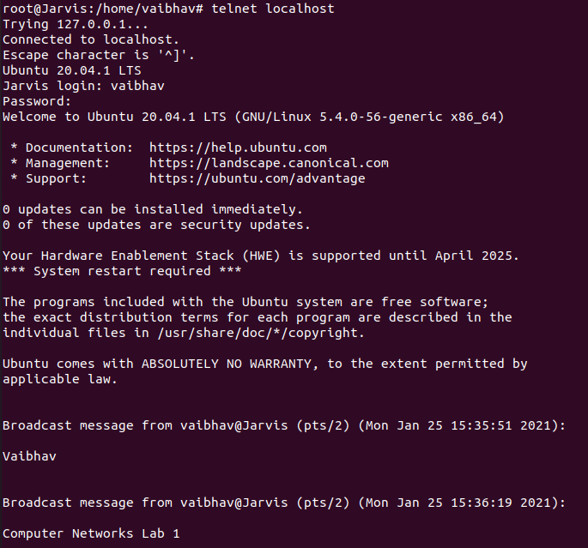

It is used to display messages/contents of files/standard input on the terminals of all the logged-in users.

1. **uptime**



It displays information such as how long the system has been running, current time, number of users logged on and the system load averages for 1, 5 and 15 minutes.

1. **nslookup**

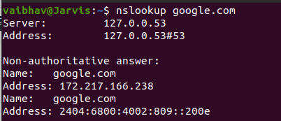

**nslookup(Name Server Lookup)** is a used to get information from the DNS server. It is used to obtain domain name or IP address mapping or any other specific DNS record.